User Manual
How to share a file



How to Securely Share a File with SpecterX
Sharing files with SpecterX works the same way no matter where you are sending them from. SpecterX integrates with your existing tools and platforms to give you a seamless experience while providing all the same security features.

Here are just a few examples:

Outlook
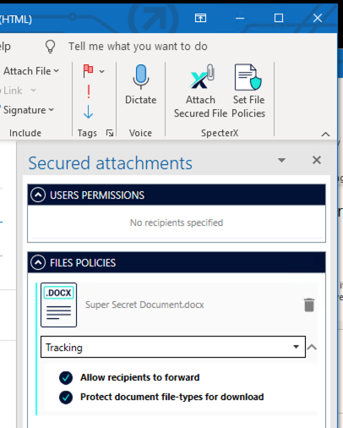

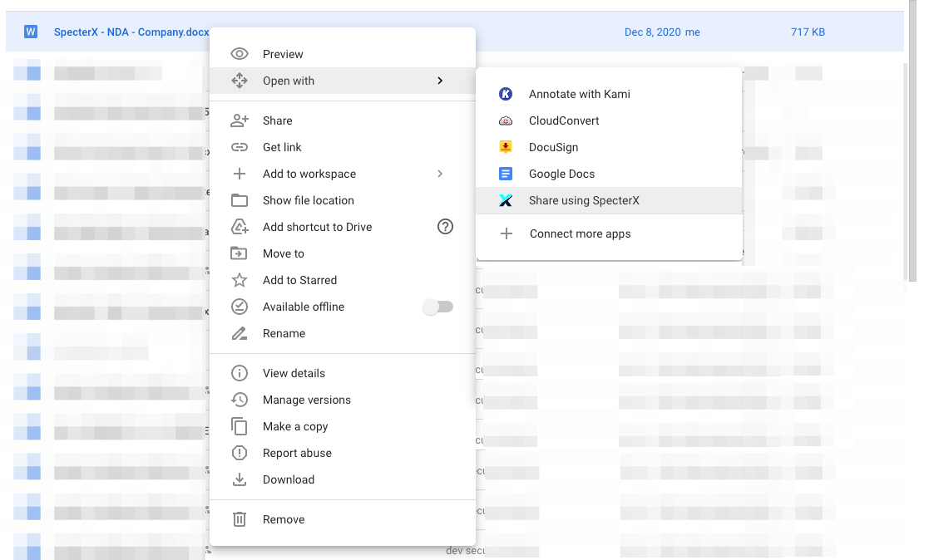
Google Drive

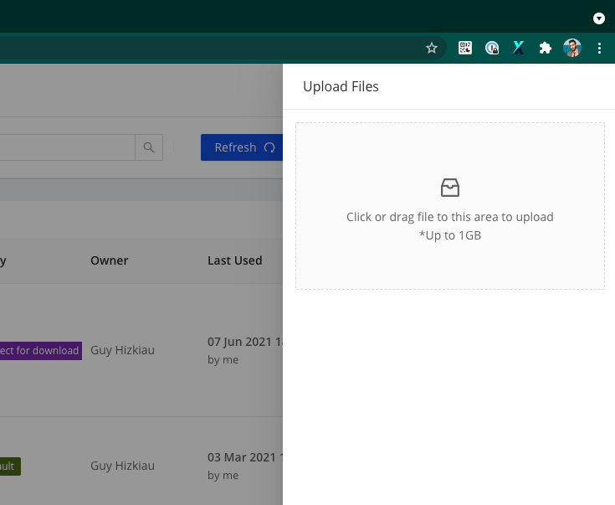
SpecterX Web Platform

With This Manual You Will Learn
Sharing a File Securely from SpecterX Web Platform 4
Logging in to the SpecterX web platform 4
Share a file 4
Sharing a File Securely from Outlook 7
Install the SpecterX Outlook Add-in 7
Login in and First Use 7
Attaching a File Securely 9

Sharing a File Securely from SpecterX Web Platform

Logging in to the SpecterX web platform
Log in to your tenant address https://XXX.specterx.com .

Sign in with your preferred authentication method.
If your organization has Microsoft or Google identities, it is recommended to choose the matching button.
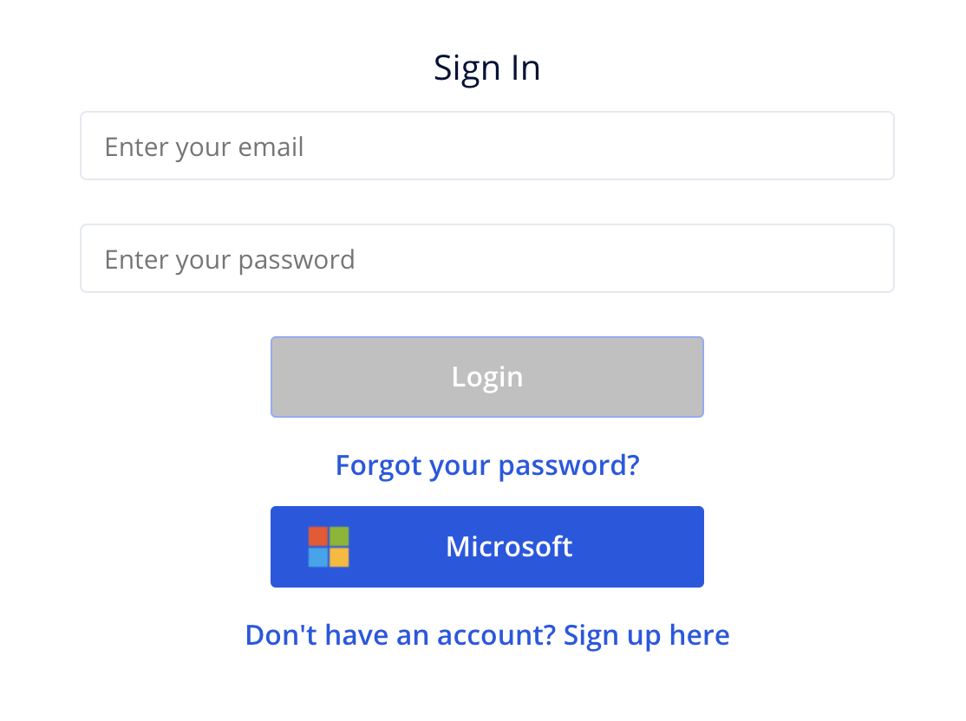

Share a file
Click the ‘Share a file’ button on the right side of the screen
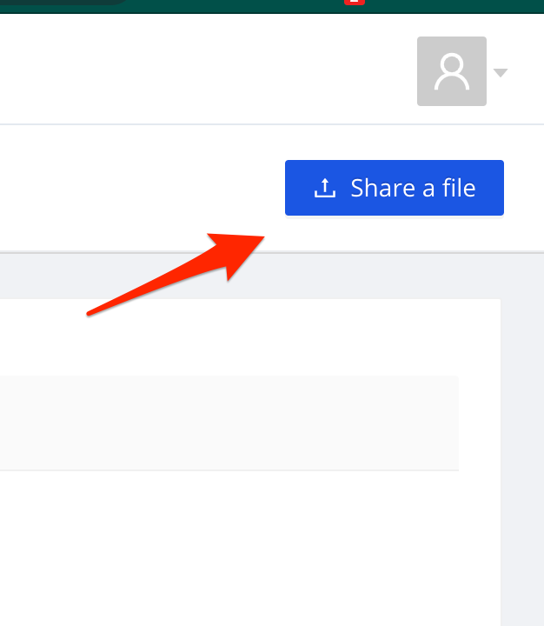

Drag your file to the gray box or click on the box and choose the files you want to share

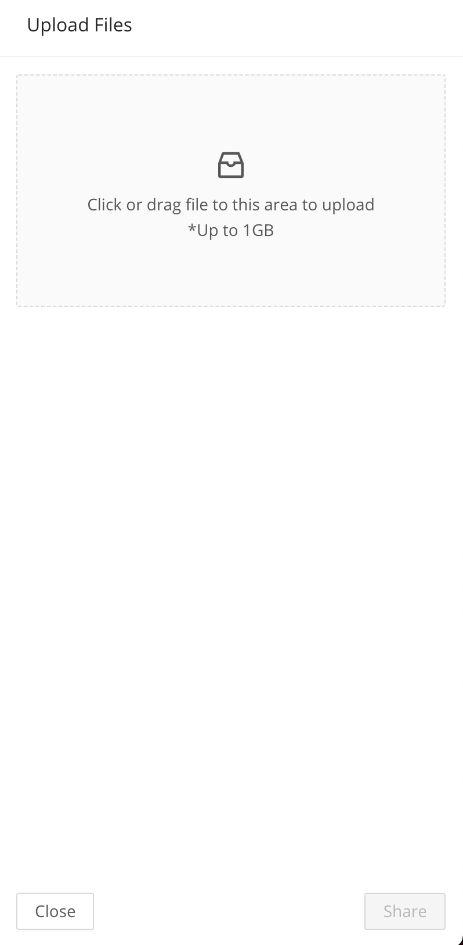
After choosing the files to share, you’ll see an uploading progress bar. The file is now being uploaded to a secure location. This process complete once the progress bar turns green and set to 100%.

Proceed to the next step by clicking the ‘Share’ button at the lower-right corner of the page.
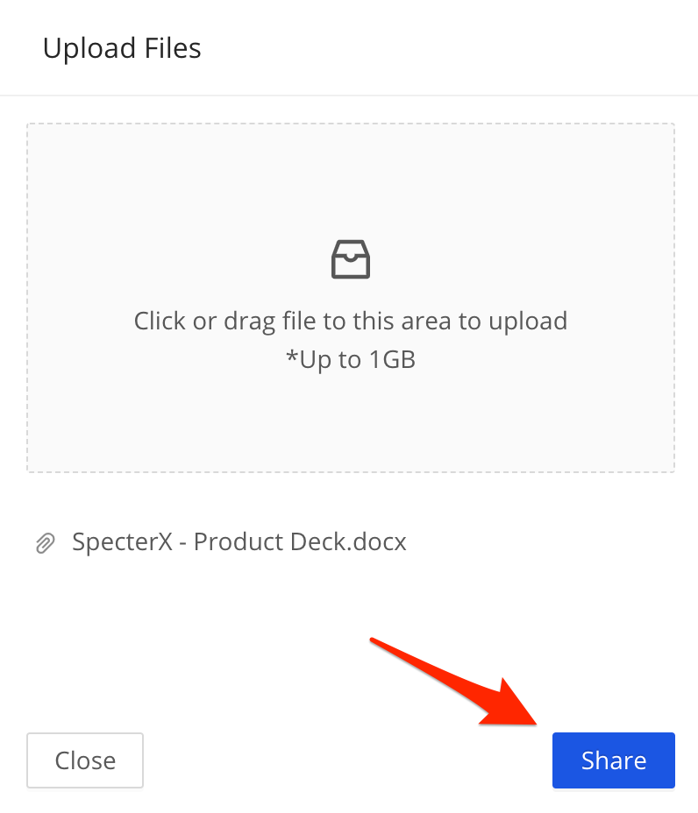

Enter the recipient email address under the ‘Share with’ section and click Add, or press the ‘Enter’ button on your keyboard.
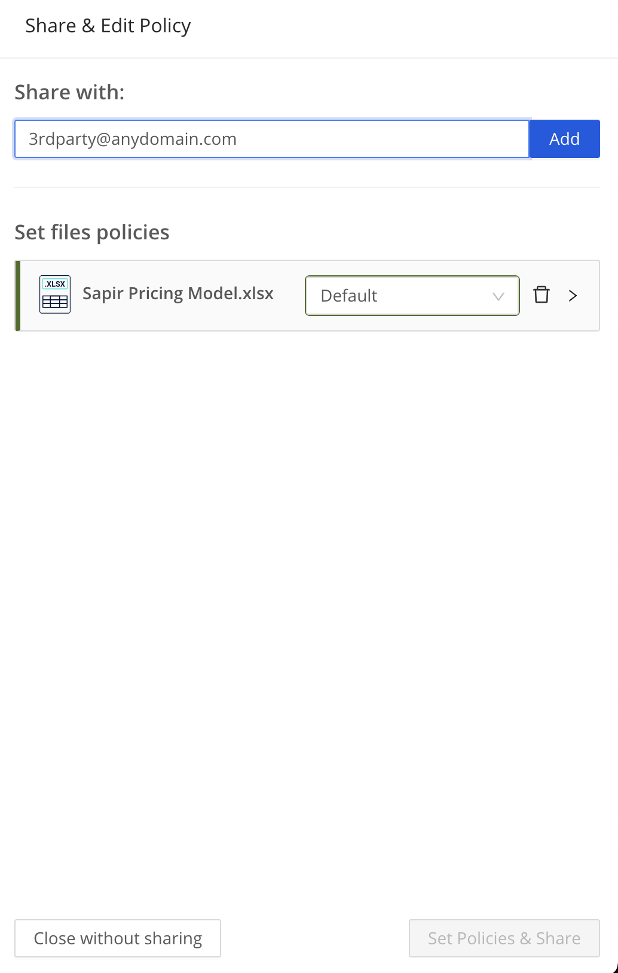

You can change the usage permissions of the recipient by clicking at the ‘Editor’ preset
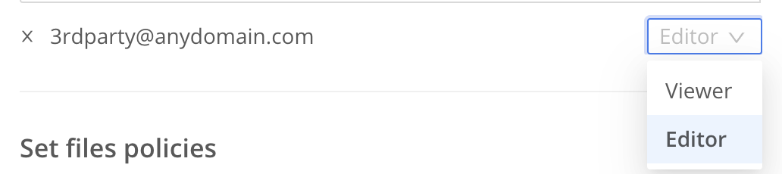

You can choose between predefined policies for each file to determine how recipients will access and use the data
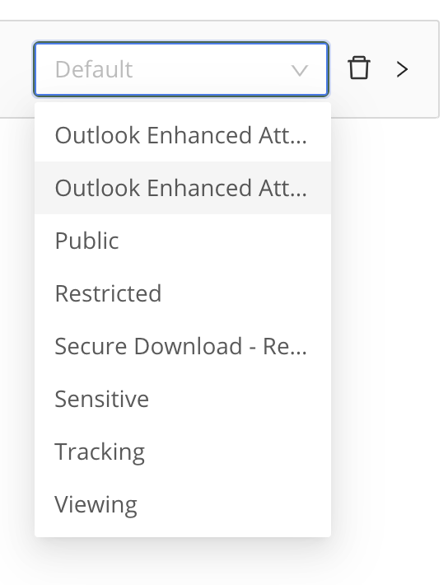

To share the file, click the ‘Set Policies & Share’ button at the bottom right corner
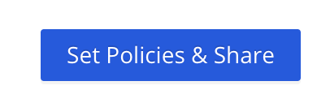
That’s it! You have shared your files successfully.
You might also want to copy the sharing link by clicking the ‘Copy to clipboard’ button, and use the link in your emails and instant-messages.

Sharing a File Securely from Outlook

Install the SpecterX Outlook Add-in
Installing the Add-in is extremely easy.
If your system administrator hasn’t installed the Add-in for you yet, download the Add-in EXE file or ask your administrator to send you a copy. Once you have it, double-click it and follow the instructions in the installer.
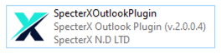

Login in and First Use
Now that you have the SpecterX Outlook Add-in installed, you can start using it to attach files. In the new window that opens, you’ll see a couple of new icons: ‘Attach Secured File’ and ‘Set File Policies’.
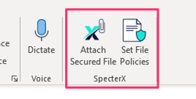
The first time you click ‘Attach Secured File’, you’ll be greeted with an authentication window. This authentication is required to connect you to the SpecterX platform. It is independent of the user connected to Outlook, however, it is recommended to use the same user for both, i.e., your organizational user.

The authentication window will look something like this:
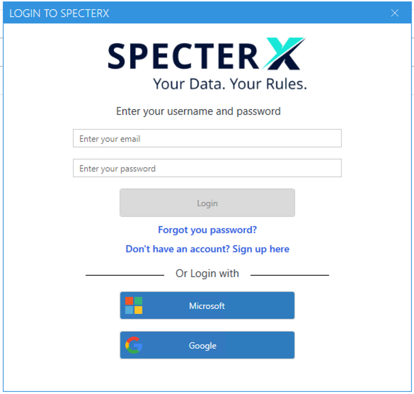

You might have a different set of authentication options, depending on your organization’s identity providers.

Choose the authentication service suitable for you and complete its steps.
If you’ve logged in before to the SpecterX web app and created a username and password for yourself, you can use these here too.
Once completed, you should be logged in to SpecterX inside the Outlook Add-in and get a “choose file” window:
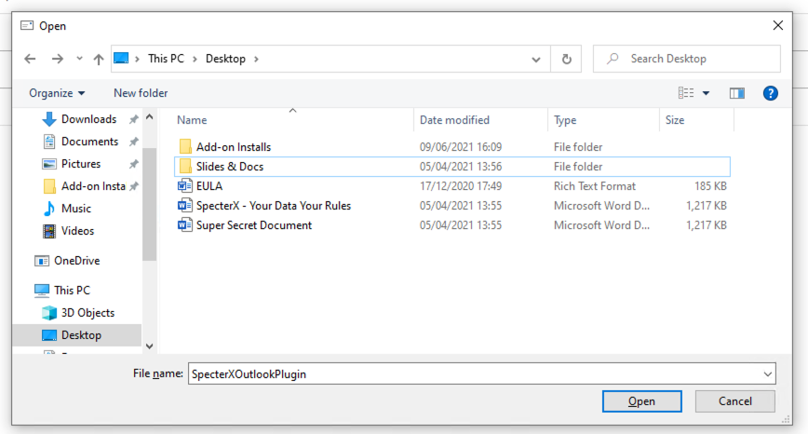

Attaching a File Securely
Now that you have the SpecterX Outlook Add-in installed and you’ve logged in with your SpecterX user, it’s time to share a file!

Click on ‘Attach Secured File’
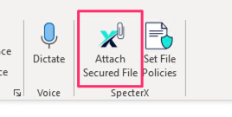
Choose a file and click ‘Open’, or double-click the file.
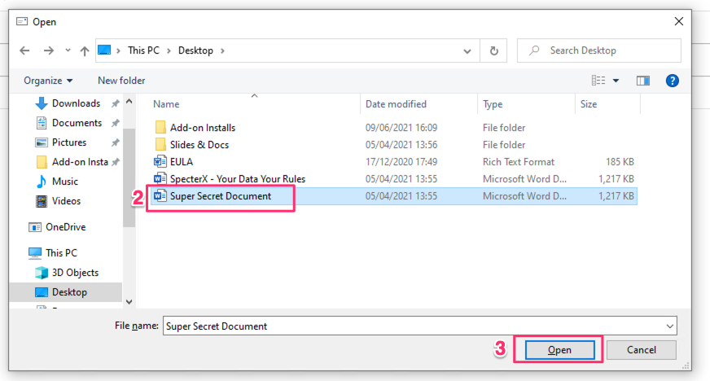

The ‘Secured attachments’ tab will open, and the original file will start uploading to SpecterX. A secure file will be attached in its stead.
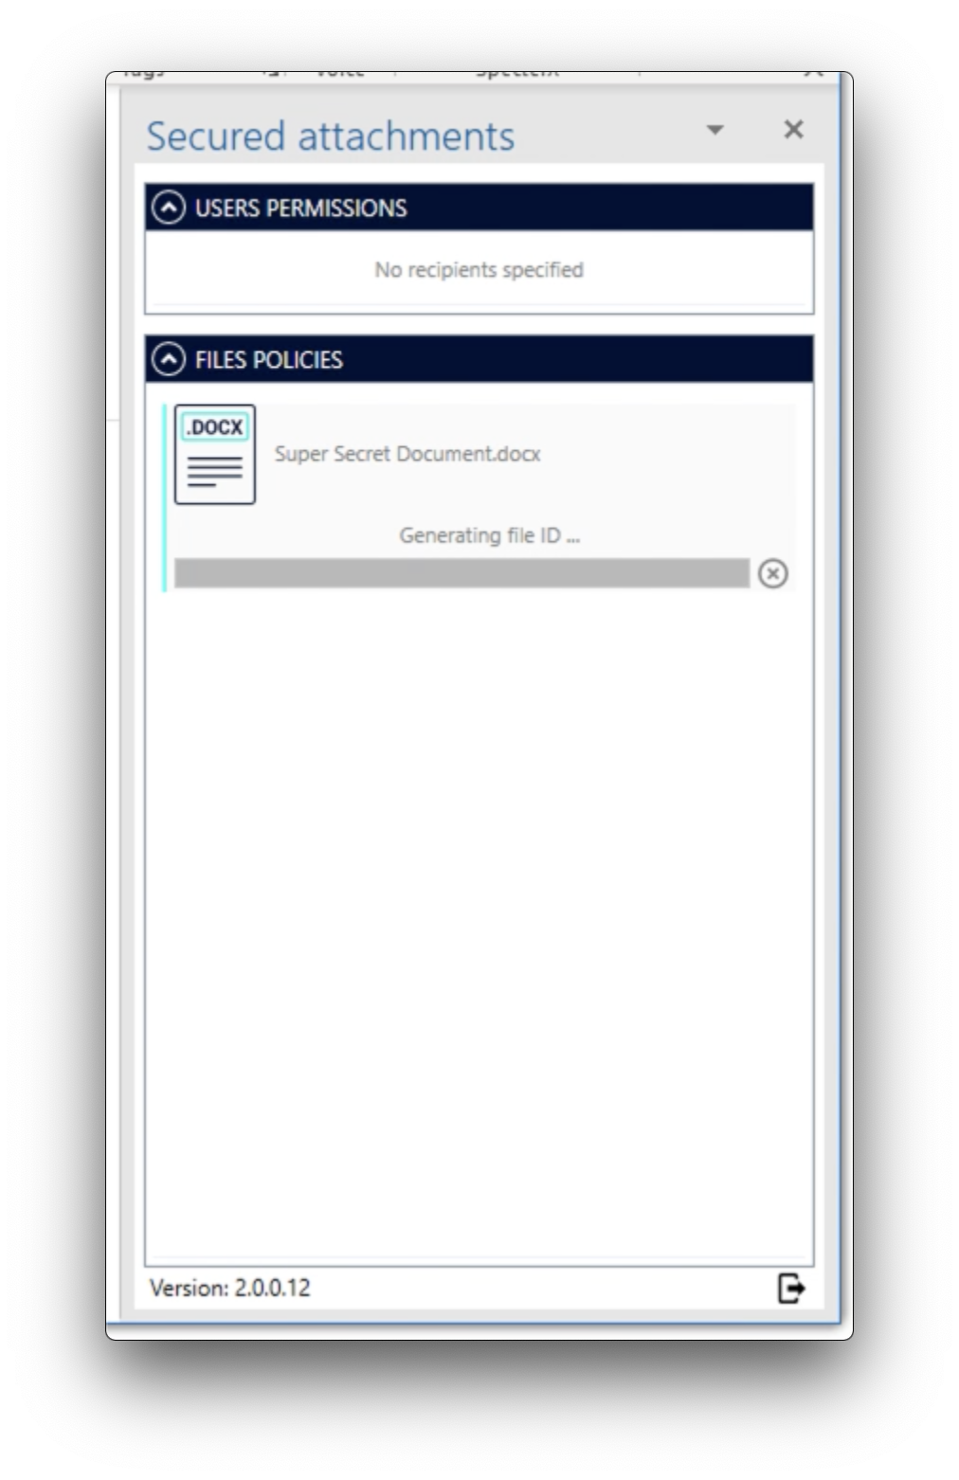
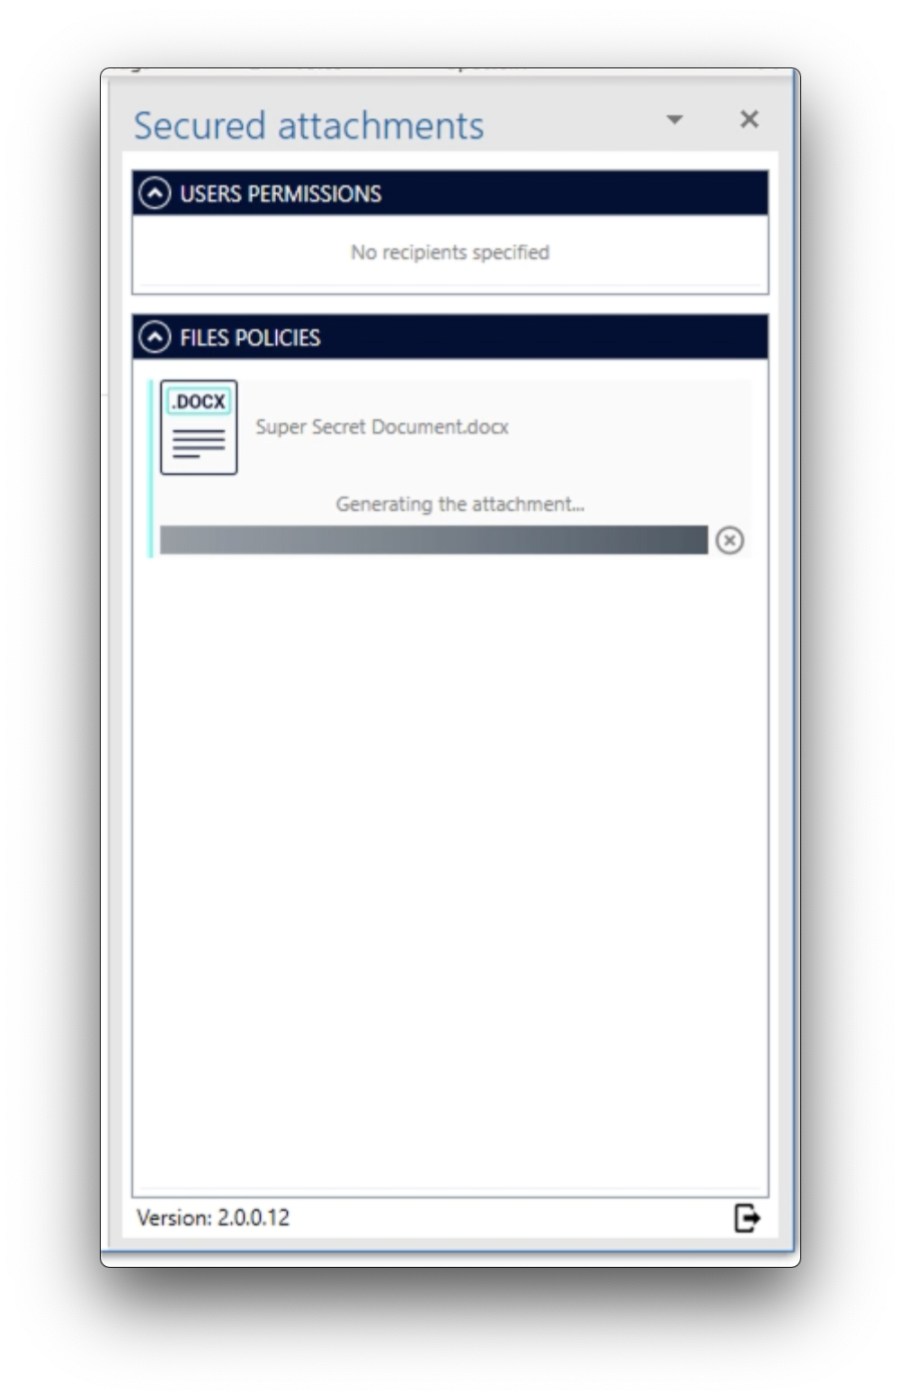
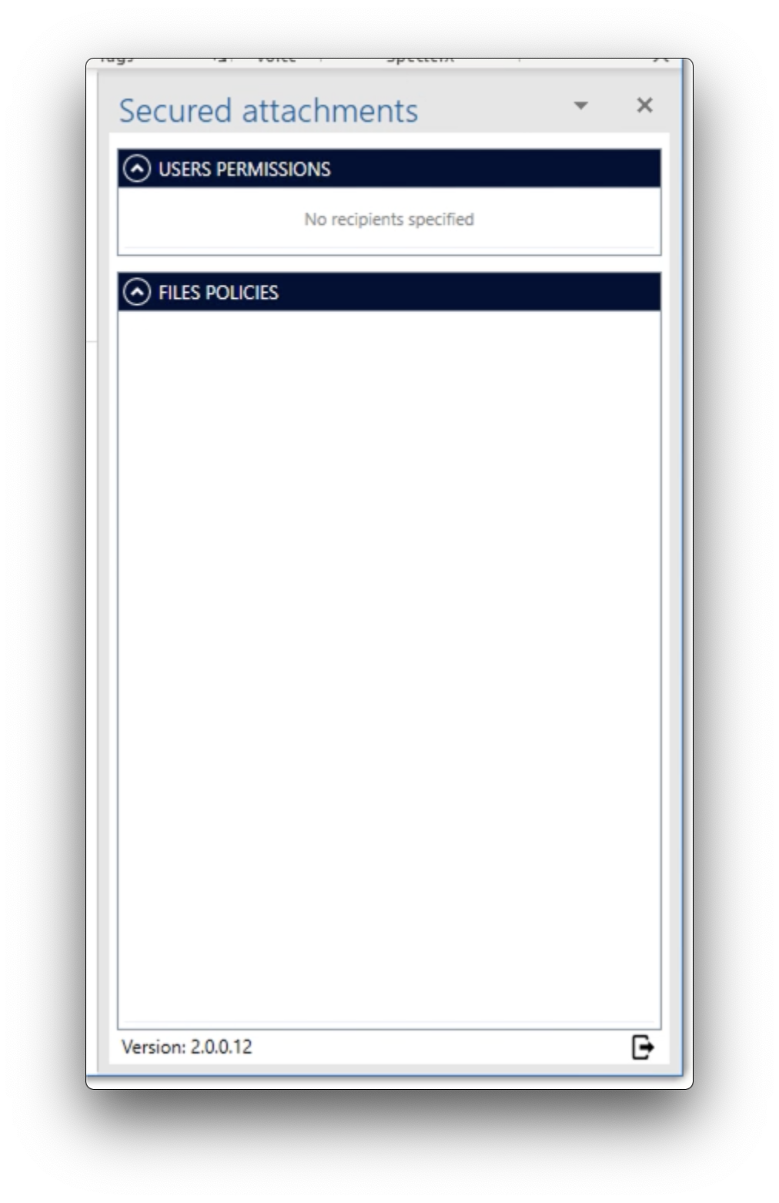
For each of the recipients added to the ‘To’, ‘CC’ and ‘BCC’ fields, you can choose the level of permissions he/she will have over the files attached to the email.
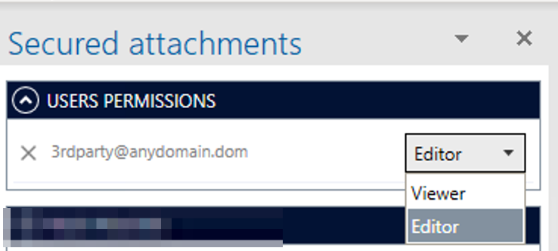

You also choose a security policy for each file to match the file’s security level. Change policies by clicking the dropdown menu, or keep the Default policy assigned by the system admin.
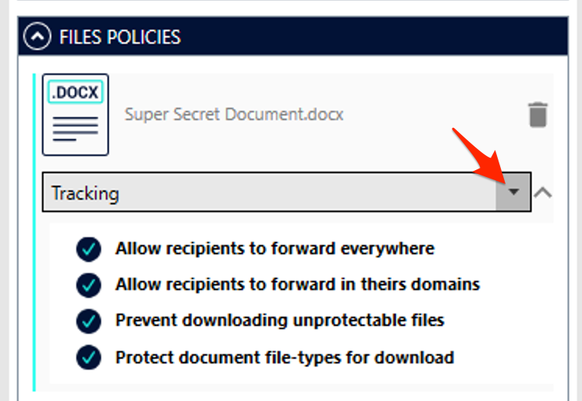

That’s it! You can continue composing your email and send it. Your attachments are secure.

